The OSI Model

The Open Systems Interconnection (OSI) reference model has served as the most basic elements of computer networking since the inception in 1984. The OSI Reference Model is based on a proposal developed by the International Standards Organization (ISO). The original objective of the OSI model was to provide a set of design standards for equipment manufacturers so they could communicate with each other. The OSI model defines a hierarchical architecture that logically partitions the functions required to support system-to-system communication.

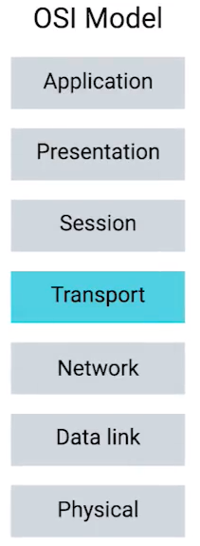

The seven OSI layers are defined as follows

* 7. Application: Provides different services to the application
* 6. Presentation: Converts the information
* 5. Session: Handles problems which are not communication issues
* 4. Transport: Provides end to end communication control
* 3. Network: Routes the information in the network
* 2. Data Link: Provides error control
* 1. Physical: Connects the entity to the transmission media

The OSI model has seven layers, each of which has a different level of abstraction and performs a well-defined function.

The application, presentation, and session layers comprise the upper layers of the OSI Model. Software in these layers performs application specific functions like data formatting, encryption, and connection management. The transport, network, data link, and physical layers comprise the lower layers, which provide more primitive network specific functions like routing, addressing, and flow controls

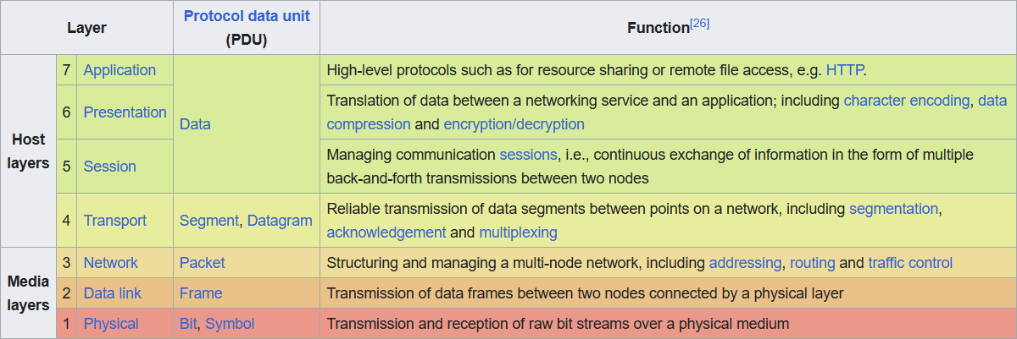

The application, presentation, and session layers comprise the upper layers of the OSI Model. Software in these layers performs application specific functions like data formatting, encryption, and connection management. The transport, network, data link, and physical layers comprise the lower layers, which provide more primitive network specific functions like routing, addressing, and flow controls.

Different Models in Literature

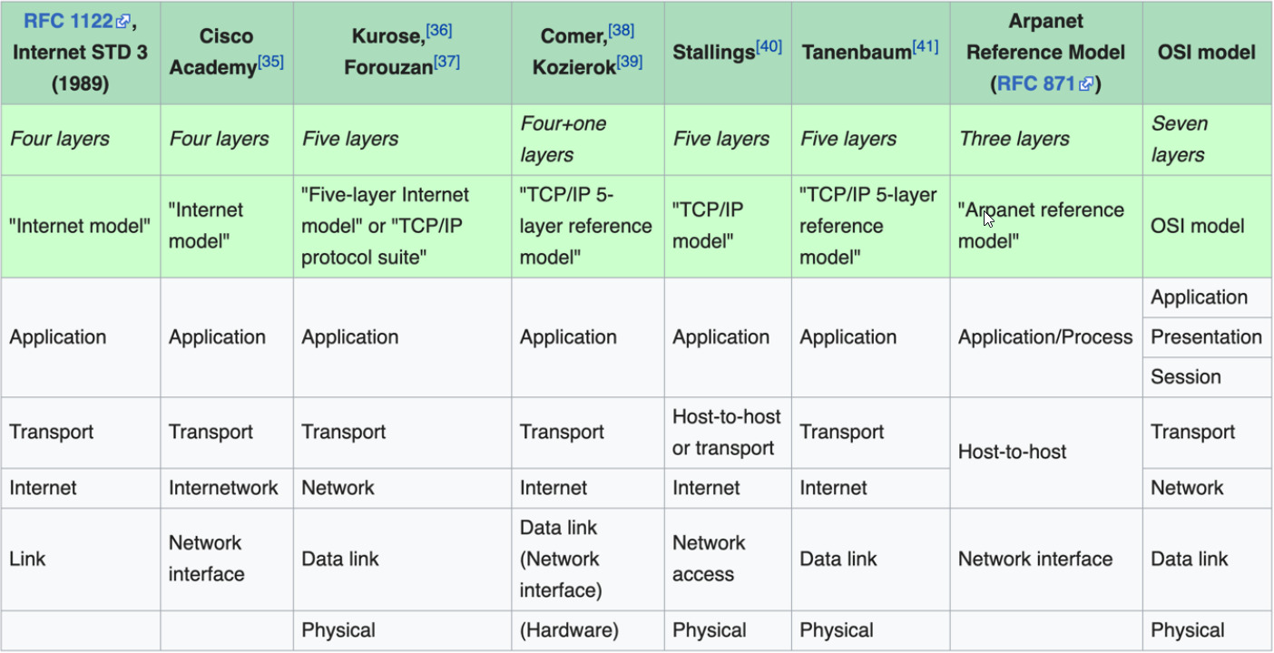

1. Physical Layer





The Physical Layer is the first and lowest layer in the OSI Model and is responsible for the physical connection between devices and the transmission of raw bits over a communication channel. It deals with the physical aspects of the network, such as how data is represented as electrical, optical, or wireless signals, how cables or wireless media are used to transmit data, and how devices are connected to the network.

The Physical Layer ensures that data sent by one device is received correctly by another device as ones and zeros, and it uses techniques like modulation and line coding to transmit data across network cables or wireless media. Modulation is the process of converting digital data into analog signals that can be transmitted over the network medium, and line coding is the process of converting digital data into electrical or optical signals that can be transmitted over cables or fibers.

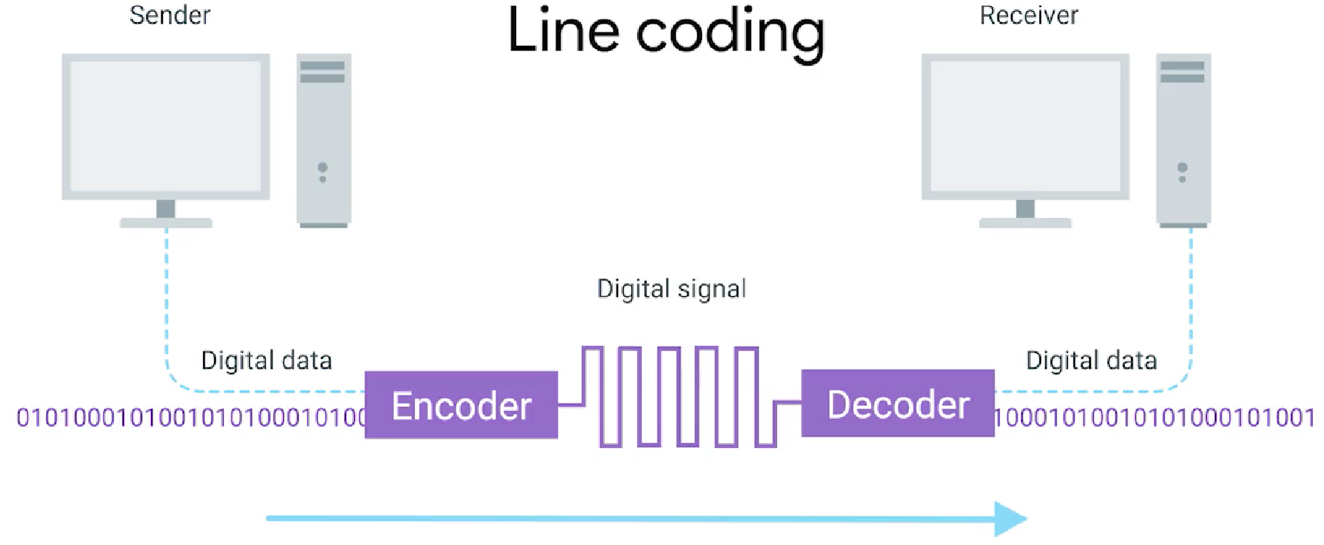

The Physical Layer also includes devices such as network ports, cables, connectors (e.g., RJ45 for Ethernet), repeaters, hubs, transceivers, and wireless antennas, which are used to connect devices to the network and establish the physical link between them. It also describes the different types of network topologies, such as bus, star, ring, and mesh, which determine how devices are interconnected in a network.

2. Data Link Layer





The Data Link Layer is the second layer in the OSI Model and is responsible for establishing a reliable link between two directly connected devices in a network. It provides error-free communication over the physical link established by the Physical Layer. The Data Link Layer ensures that data is transmitted without errors and in the correct sequence between devices, typically through the use of protocols such as Ethernet, Wi-Fi, or Point-to-Point Protocol (PPP).

The Data Link Layer is responsible for framing, or packaging, the data received from the upper layers into data frames that can be transmitted over the physical medium. It also provides mechanisms for detecting and correcting errors that may occur during transmission, such as checksums or CRC (Cyclic Redundancy Check).

**Ethernet Frame:**

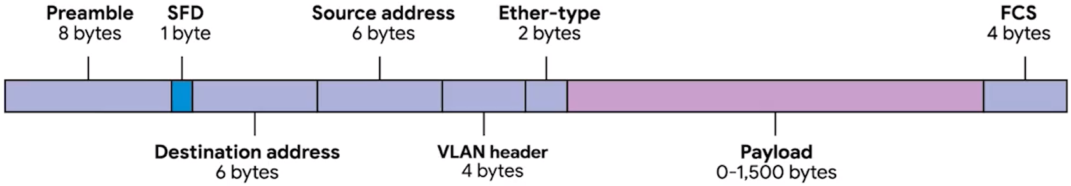

The Data Link Layer includes devices such as switches, bridges, and network interface cards (NICs) that operate at this layer and are responsible for forwarding data frames between devices within the same local area network (LAN)

The Data Link Layer also manages the flow of data between devices to prevent data overload, using techniques such as flow control and media access control (MAC). Flow control regulates the amount of data transmitted to avoid overwhelming the receiving device, while MAC determines how devices share the same network medium to avoid collisions and ensure efficient data transmission.

3. Network Layer





The Network Layer is responsible for facilitating communication between different networks in the OSI Model. It uses logical addresses, such as IP addresses, to identify devices and routes data packets between networks. It employs routing protocols, such as OSPF, RIP, and BGP, to determine the optimal path for data packets to reach their destination across different networks. Additionally, it provides services such as fragmentation and reassembly of data packets to ensure efficient transmission, and manages congestion control mechanisms to prevent network congestion and maintain optimal performance.

**IP Datagram Header:**

At the Network Layer, routers, layer 3 switches, and firewalls operate to inspect and forward data packets based on their destination IP addresses. It plays a crucial role in enabling communication between devices on different networks and allows for the establishment of end-to-end connections across multiple

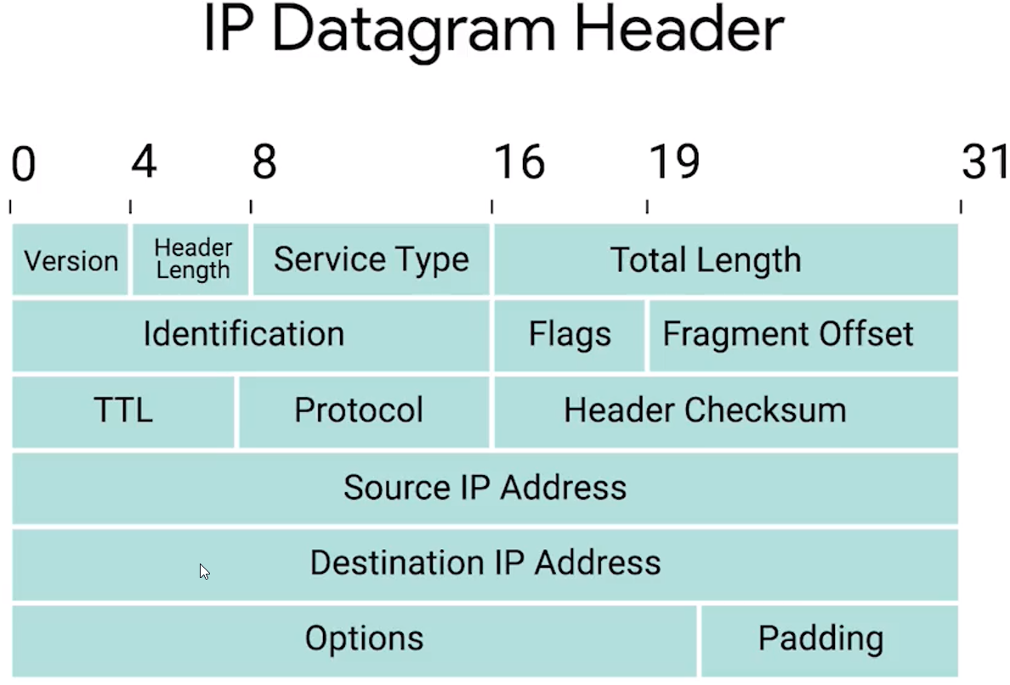

network segments. Routing is a key function of the Network Layer, where routers analyze the destination IP address in the packet header and determine the best path for the packet to reach its destination. Routers use routing protocols, such as OSPF (Open Shortest Path First) to exchange information and make routing decisions based on factors like network topology, traffic load, and network conditions.

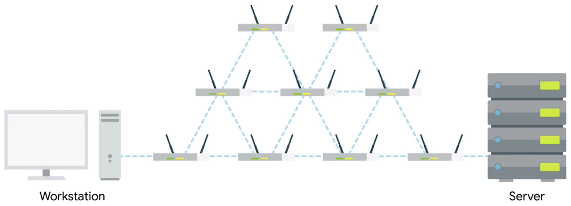

4. Transport Layer





The Transport Layer is responsible for providing reliable and efficient communication between devices in the OSI Model. It ensures that data is delivered accurately and in the correct order, and it establishes end-to-end connections between applications running on different devices. The Transport Layer uses protocols such as TCP (Transmission Control Protocol) and UDP (User Datagram Protocol) to manage the transmission of data packets and provide reliable or unreliable data delivery services, respectively.

**TCP Header:**

The Transport Layer segments data received from the upper layers into smaller units called segments or datagrams, and adds necessary headers to these segments to enable their proper delivery. It also manages flow control, congestion control, and error recovery mechanisms to ensure efficient and reliable data transmission.

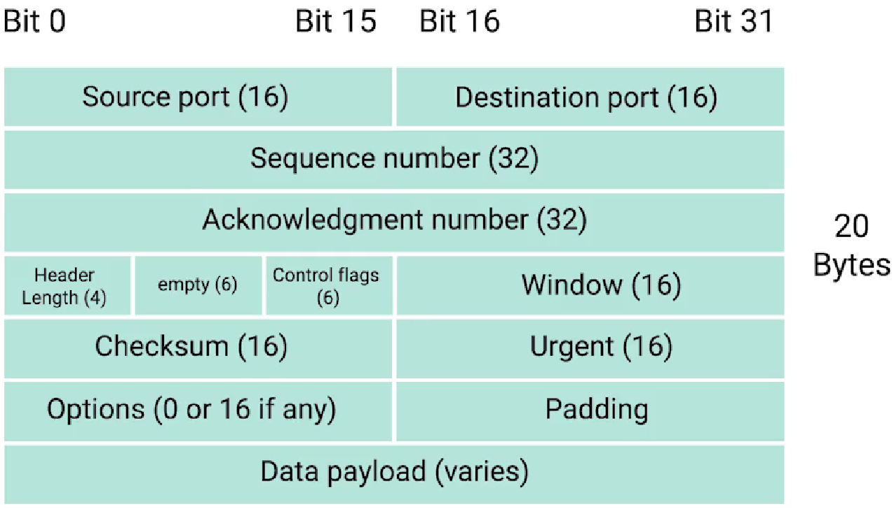

The Transport Layer is responsible for reassembling received segments or datagrams into complete data at the receiving end, and passing it to the upper layers for further processing. The Three-way handshake is a process that occurs at the Transport Layer. It is used by the TCP. After the three-way handshake, TCP connection is established for reliable data exchange between client and server.

* SYN (synchronize): Client sends a request to establish a connection.
* SYN-ACK (synchronize-acknowledge): Server responds with acknowledgment and willingness to establish a connection.
* ACK (acknowledge): Client acknowledges the server's response.
* FIN (finish): Either client or server sends a request to terminate the connection.

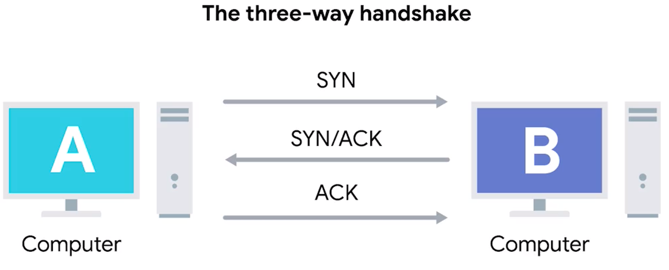

5. Session Layer



The Session Layer is responsible for establishing, maintaining, and terminating communication sessions between devices in a network. It provides services for session management, including session establishment, synchronization, and session recovery in case of failures.

The Session Layer allows devices to establish a session, which is a logical connection between them for the purpose of data exchange. It ensures that communication sessions are properly initiated and terminated, and that data is exchanged in an organized and reliable manner. It also manages session checkpoints and recovery points, which allow for resuming interrupted sessions.

The Session Layer may also provide services such as session encryption, which secures the data transmitted during a session, and session identification, which uniquely identifies a session among other sessions. Additionally, the Session Layer may include features such as session timeouts, session logging, and session prioritization to ensure efficient and reliable communication between devices.

6. Presentation Layer



The Presentation Layer in the OSI Model is responsible for the formatting, encoding, and encryption of data to be transmitted across a network. It ensures that data is presented in a standardized and compatible format that can be understood by the receiving device, regardless of the differences in data representation and syntax used by different devices and applications.

The Presentation Layer is responsible for data compression, encryption, and decryption to ensure data security and confidentiality during transmission. It also handles data conversion between different data formats, such as text, images, audio, and video, to ensure that data is correctly interpreted by the receiving device.

Furthermore, the Presentation Layer may provide services such as data integrity checking, error correction, and flow control to ensure reliable data transmission. It also handles data syntax and semantics, including data formatting, serialization, and deserialization, to ensure that data is correctly interpreted by the receiving device or application.

7. Application Layer

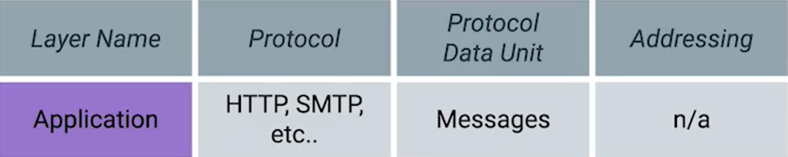

The Application Layer is the topmost layer in the OSI Model and is responsible for providing communication services directly to end-users and applications. It enables applications to interact with the network and exchange data with other applications or devices, making it the layer where users interact with the network.

The Application Layer supports a wide range of application protocols, such as HTTP for web browsing, FTP for file transfer, SMTP for email, DNS for domain name resolution, and many others. These protocols define how data is formatted, transmitted, and interpreted between applications and devices.

The Application Layer provides services that enable applications to communicate across the network, including data formatting, data encryption, authentication, and authorization. It also provides interfaces for applications to access network resources, such as databases, printers, and other shared resources.

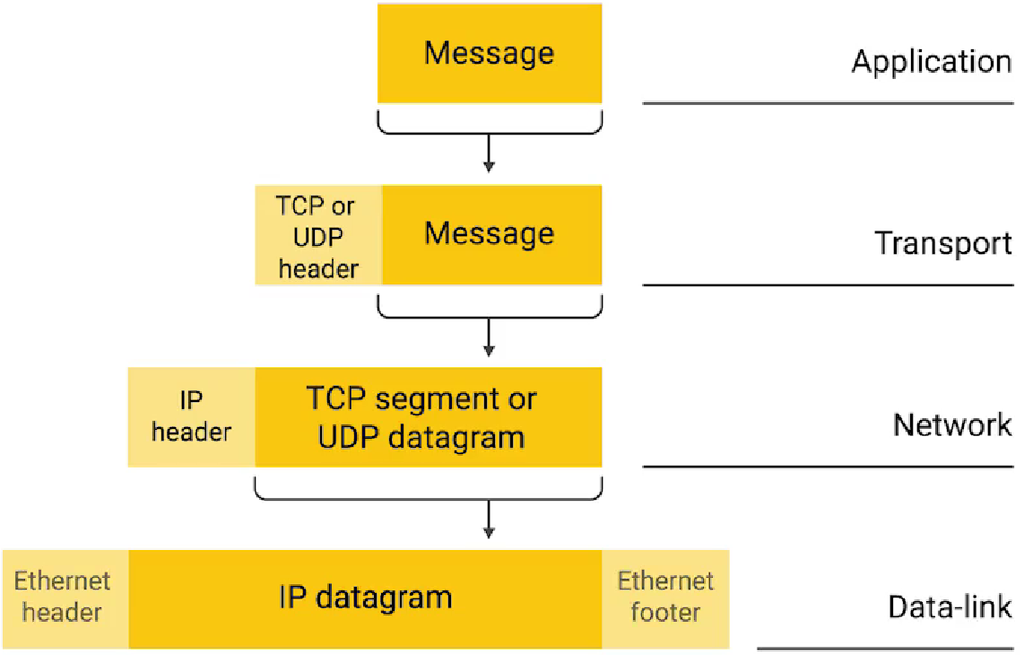

Furthermore, the Application Layer may include features such as user authentication, error handling, logging, and session management to ensure secure and reliable communication between applications and devices. It also enables application-specific functionalities, such as multimedia streaming, virtual private networks (VPNs), and remote desktop access.

**All Layers in action through an example of delivery:**

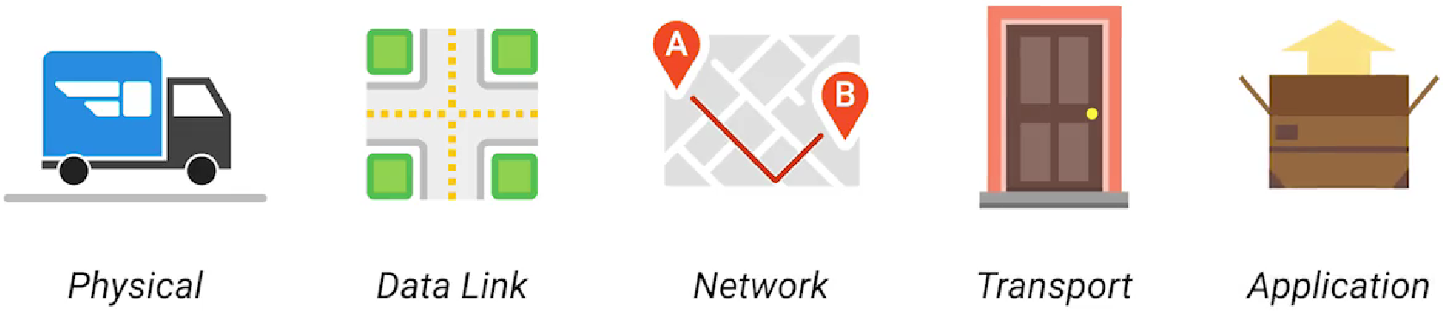

References

**Shreyas-Daptare** “The OSI Model basics.”

GitHub Repository. (April 2023).

URL: <https://github.com/Shreyas-Daptare/The-OSI-Model>

**Rachelle Miller** “The OSI Model: An Overview.”

SANS White Papers (September 2001).

URL: [The OSI Model: An Overview | SANS Institute](https://www.sans.org/white-papers/543/?show=osi-model-overview-543)

**Google Docs** “Supplementary reading on Networking.”

Bits and Bytes of Computer Networking [Coursera] (2018).

URl: [The Bits and Bytes of Computer Networking from Grow with Google - YouTube](https://www.youtube.com/playlist?list=PLVext98k2evj_YOy-PsFxNiqhhSU3bYFV) ,

[The Bits and Bytes of Computer Networking | Coursera](https://www.coursera.org/learn/computer-networking)

Thank You.